**DESIGN EQUATIONS**

The following equations are commonly used in the design of loop resonators discussed in this chapter.

**Length of the resonator**

The length of the resonator is taken as one guide wavelength $λ_{g}$

$λ_{g}=\frac{λ_{0}}{\sqrt{ε_{eff}}}$ (4.1)

where $λ_{g}$ is the guided wavelength

$λ_{0}$ is the free space wavelength

and $ε_{eff}$ is the effective dielectric constant.

Effective dielectric constant is calculated by using the standard equation (4.2)

**Effective dielectric constant**

$ε_{eff}= \frac{ε_{r}+1}{2}+ \frac{ε_{r}-1}{2} \left[{\left(1+12\left(\frac{d}{w}\right)\right)}^{\frac{1}{2}}+0.04{\left(\left(1-\frac{w}{d}\right)\right)}^{2}\right]$ (4.2)

w - width of the conductor

d - height of the substrate

εr - relative dielectric constant of the substrate

**Width** **of the conductor**

$\frac{w}{d}=\frac{8exp⁡(A)}{expexp \left(2A\right) -2}$ (4.3)

where $A=\frac{Zo}{60}{\left\{\frac{ε_{r}+1}{2}\right\}}^{0.5}+\frac{ε_{r}-1}{ε_{r}+1}\left\{\frac{0.11}{ε_{r}}+0.23\right\}$ (4.4)

Zo  is the characteristic impedance of the microstrip line

**Characteristic impedance**

Zo =  *ln $\left(\frac{8d}{Wd}\right)$* +0.25 $\frac{w}{d}$ (4.5)

Where $η$ = 120 π is the wave impedance in free space.

**Coupling gap**

$∆L=0.421d\left(\frac{ε_{eff}+.3}{ε_{eff}-.258}\right)\left(\frac{\frac{w}{d}+0.262}{\frac{w}{d}+0.818}\right)$ (4.6)

**4.3 RING RESONATOR**

Closed loop resonators, in comparison with the microstrip linear resonators, do not suffer from the open end effects and are most popularly known to give more accurate results. Among the closed loop resonators, ring resonators are distributed line resonator whose radius is ‘r’ as shown in Figure 4.1.

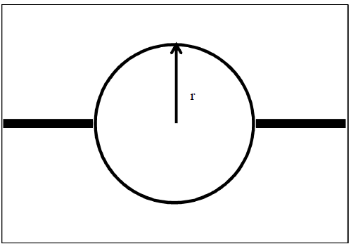

**Figure 4.1 Structure of ring resonator**

The ring will resonate at its fundamental frequency fo which is given by,

*f*o = (4.7)

The higher resonant modes occur at *f*= *n* *f*ofor *n*=2, 3,

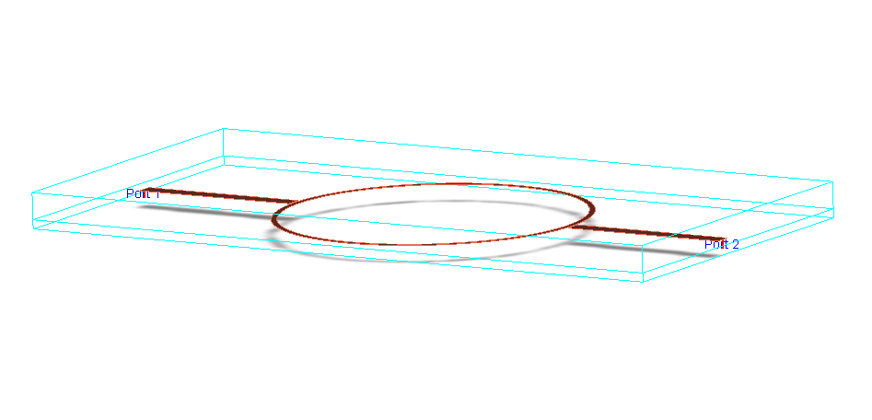

**Figure 4.2 Simulated ring resonator**

The simulated structure of the ring resonator is shown in Figure 4.2. The resonator responses have been determined by using ADS simulation software. The microstrip line ring resonator includes the feed lines, a closed conductor loop and coupling gaps. The resonator is one guide wavelength long which is designed for fundamental frequency of 1 GHz. The proposed sensor has been fabricated on a FR4 substrate (εr=4.6) with the dielectric thickness of 0.762 mm. The design parameters used for the resonator sensor are :

Radius of the ring resonator = 26.5 mm,

Strip width of the resonator = 1.6 mm

Feed length = 40mm

Coupling gaps = 0.35 mm

and Resonator length = 170mm.

The resonator length is found out by the equations (4.1) and (4.2). The area of the resonator is calculated as 2206 sq.mm.

The two-port ring resonator shown in Figure 4.1 and Figure 4.2 includes feed lines, a closed transmission line loop and coupling gaps. The function of the ring resonator is based on simple equation:

$2π r = n { λ}_{g}$